**Executive Women in Motion:  
Pathways to the Senior Executive Service**

The White House  
Eisenhower Executive Office Building  
Conference Room 430

March 15, 2016  
1:30 – 4:30 p.m.

**1:30 p.m. Elnora Wright  
 Welcome & Opening Remarks** Program Manager, Governmentwide Mentoring  
 U.S. Office of Personnel Management

**Beth Cobert**  
 Acting Director  
 U.S. Office of Personnel Management

**1:45 p.m. Cecilia Muñoz  
 Journey of a Senior Official in** Assistant to the President and **the Obama Administration** Director of the Domestic Policy Council   
 The White House

**2:00 p.m. Megan Smith**Assistant to the President and   
U.S. Chief Technology Officer The White House

**2:15 p.m. Yadira Guerrero  
 Overview of the Executive Core** Learning and Development Specialist **Qualifications: Preparing for** Senior Executive Service & Performance Management **the Senior Executive Service** U.S. Office of Personnel Management

**3:00 p.m. Introduction of SES Mentors**

**3:15 p.m. Table Discussions (Round 1)**

**3:45 p.m. Table Discussions (Round 2)**

**4:15 p.m. Closing Remarks**

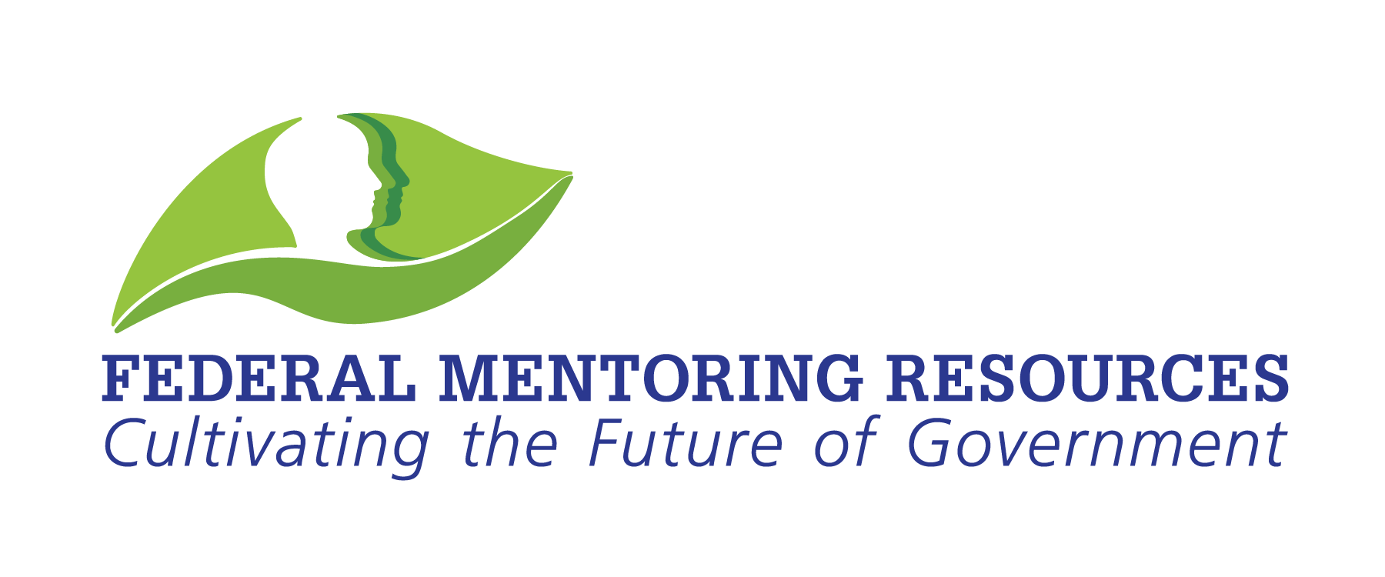 **4:30 p.m. Networking**